**Figure 9.** Model performance comparison with six different input features for dual resampling with a ratio of 1:1 between the non-cheater and cheater classes.

**Figure 10.** Model performance comparison with six different input features for dual resampling with a ratio of 2:1 between the non-cheater and cheater classes.

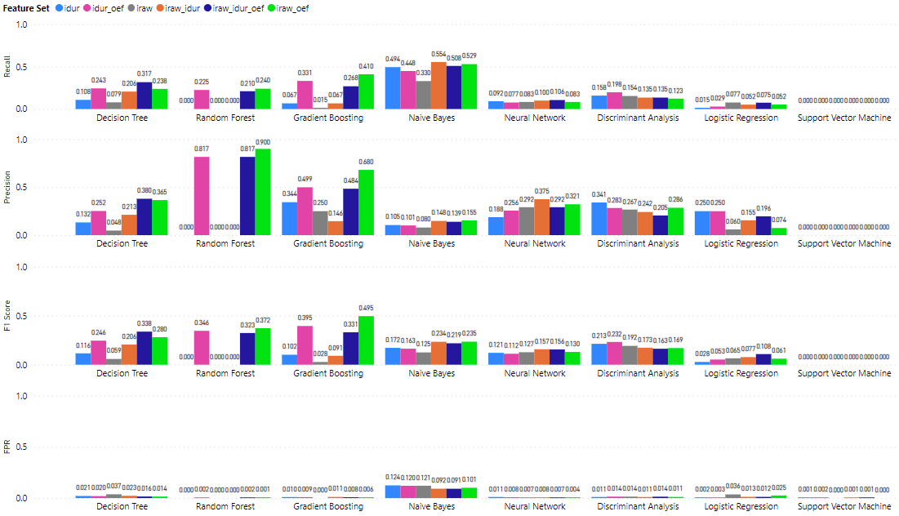

**Figure 21.** Model performance comparison with six different input features without resampling methods applied.

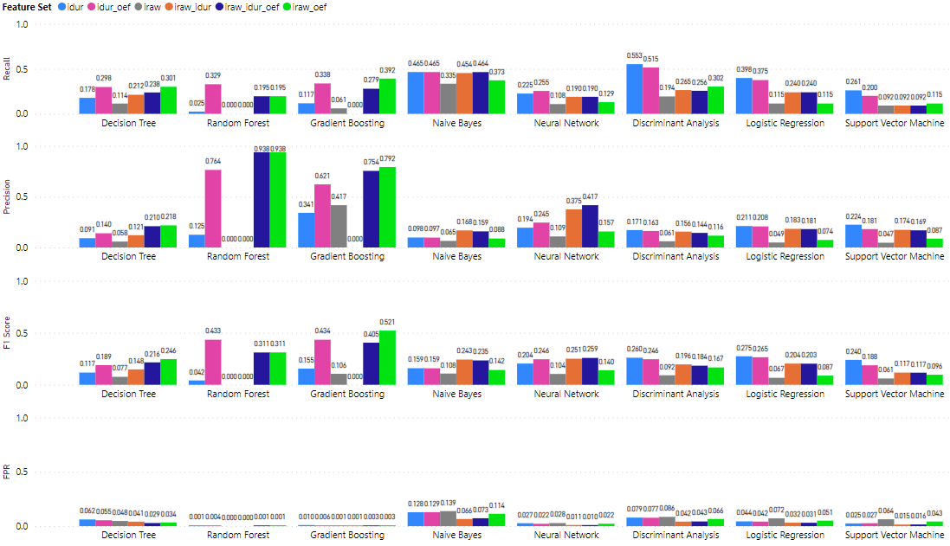

**Figure 22.** Model performance comparison with six different input features for oversampling SMOTE only with a ratio of 2:1 between the non-cheater and cheater classes.

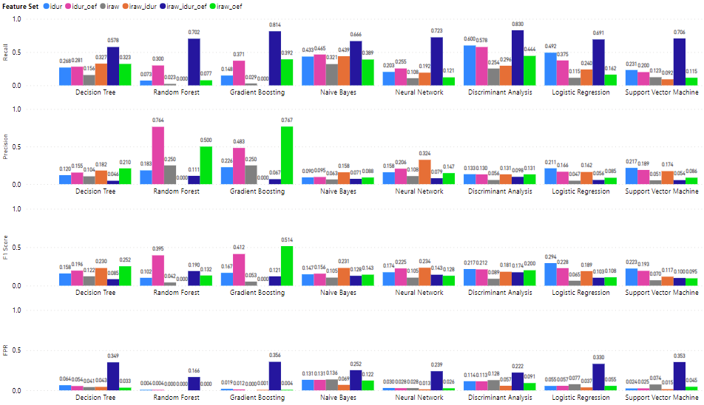

**Figure 23.** Model performance comparison with six different input features for oversampling SMOTE only with a ratio of 1:1 between the non-cheater and cheater classes.

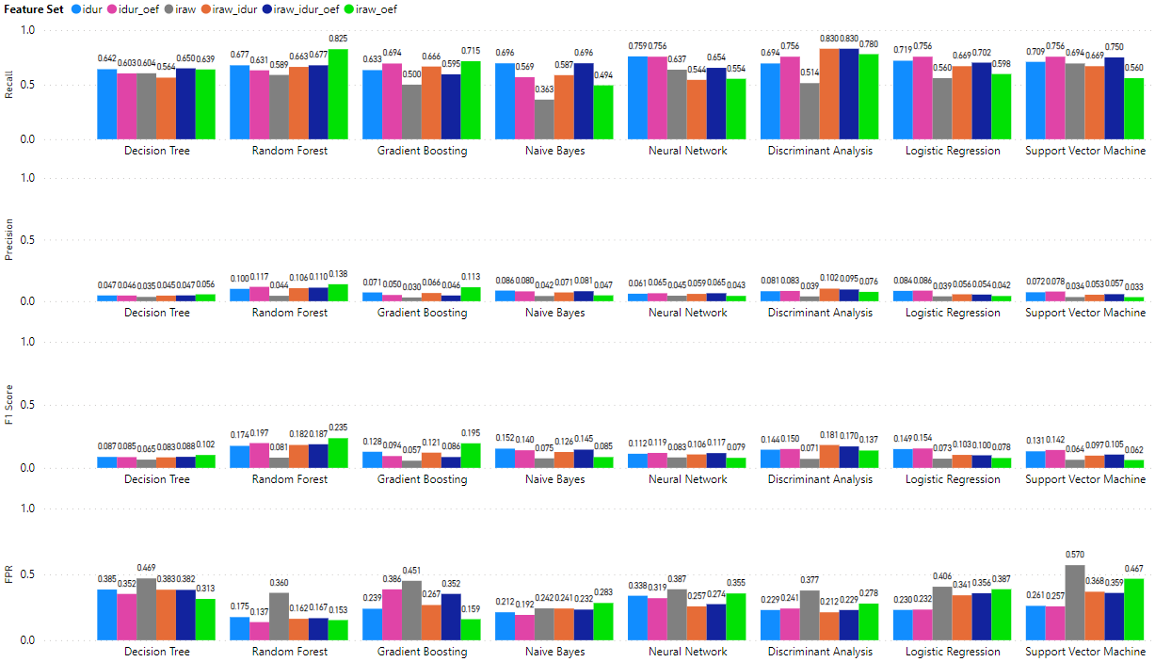

**Figure 24.** Model performance comparison with six different input features for under-sampling only with a ratio of 1:1 between the non-cheater and cheater classes.

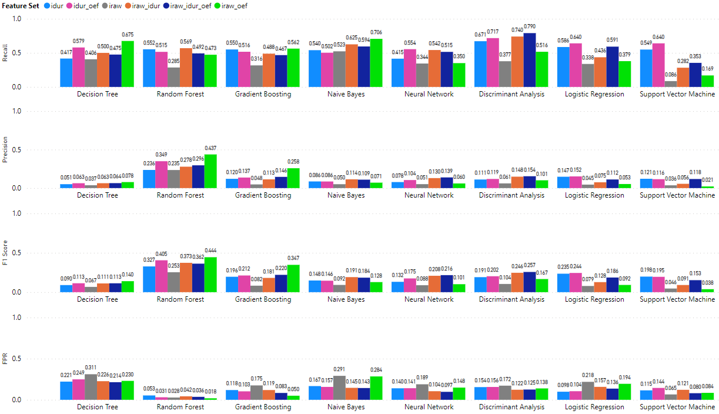

**Figure 25.** Model performance comparison with six different input features for under-sampling only with a ratio of 2:1 between the non-cheater and cheater classes.